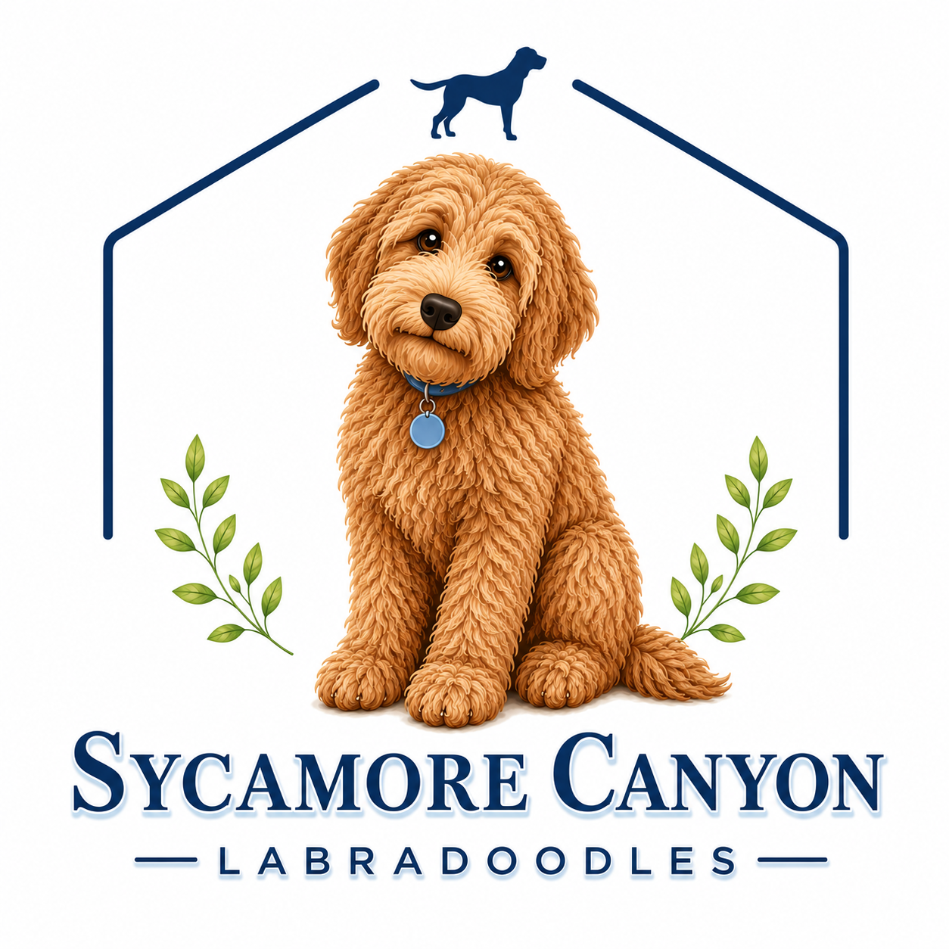
HEALTH AND WELLNESS AGREEMENT
Seller Name: Sycamore Canyon Labradoodles
Address: 6059 Speyside Rd, Riverside, CA 92507
Phone: (951) 333-1569
Buyer Name: ________________________________________________
Address: ___________________________________________________
Phone: __________________ Gmail: ____________________________
Date of Sale: __________________
Before-Tax Price: ____________ Reservation Deposit: _____________
State Sales Tax: 8.75%
Total Due: __________________ Delivery Date: ___________________

Description of the Puppy or Dog
- Breed: Multi-Generational Australian Labradoodle (10th Generation)
- Gender: ( ) Male ( ) Female
- Color: ___________
- DOB: ___________________ (Puppies must be 8 weeks or older before delivery)
- Puppy Call Name: Sycamore Canyon ________________ (Puppy’s Given Name)
- Chip Registration Number: ___________________________
- Sire: _________________________________
- Dam: _________________________________

SECTION 1: SELLER REPRESENTATIONS & WARRANTIES
Breed Standards: The Seller warrants that this puppy/dog is a 10th-generation Australian Labradoodle, carefully bred to exhibit the breed standard's signature temperament, structure, and quality.
WALA Registration: The puppy/dog will be registered with the Worldwide Labradoodle Association (WALA). The Seller will finalize official registration documentation and make it available to the Buyer after receiving standard veterinary confirmation of the spay/neuter procedure.
Initial Health Guarantee (72-Hour Return): The Seller guarantees that the puppy/dog is in good health at the time of delivery and has received all age-appropriate vaccinations as detailed in the accompanying health log.
  - If a licensed veterinarian determines in writing within 72 hours of delivery that the puppy/dog is unwell or unsound, the Buyer may return the dog to the Seller for a full refund of the purchase price.
  - Veterinary care, diagnostics, or transit costs incurred during this initial 72-hour period remain the Buyer's responsibility.
  - Two-Year Genetic Health Warranty: The Seller proudly provides a two-year (2) health warranty from the dog's date of birth against any significant, life-altering genetic conditions that fundamentally impact the dog’s quality of life.
  - Exclusions: This warranty excludes routine dental matters, minor hernias, environmental or food allergies, and any direct medical complications arising from the spay/neuter procedure. It does not cover conditions resulting from improper care, accidental injury, or trauma sustained post-delivery.
  - Evaluation Procedure: The Buyer will share the clinical diagnosis and relevant medical history with the Seller. To ensure the highest standard of accuracy, the Seller reserves the right to request a confirming evaluation from an independent veterinarian at the Seller’s expense.
  - Remedies: Should a genetic condition be confirmed, the Seller and Buyer will collaborate gracefully to select one of the following remedies:
    - A replacement puppy of equal quality from the next available litter, subject to seasonal scheduling. 2. Financial assistance toward the dog's ongoing veterinary treatment up to 50% of the initial purchase price, allowing the dog to remain in the comfort of the Buyer's home.
SECTION 2: BUYER OBLIGATIONS & CARE AGREEMENTS
- Companion Pet Only: The Buyer will keep this dog strictly as a cherished companion pet and agrees that the dog is not intended for breeding purposes.
- Mandatory Spay/Neuter: To support long-term health and development, the Buyer agrees to have the dog spayed or neutered before 18 months of age. The Seller is to be provided with a copy of the veterinary receipt or certificate upon completion. Timely completion of this procedure is required for maintaining the 2-Year Genetic Health Warranty.
- Standard of Excellence in Care: The Buyer pledges to provide an exemplary standard of care, including premium nutrition, consistent coat grooming, positive behavioral training, routine parasite prevention, and attentive annual wellness exams and vaccinations.
- Naming Tradition: The Buyer agrees that the dog's official registered name with WALA will begin with the prefix "Sycamore Canyon" (e.g., Sycamore Canyon [Name]).
- Exclusivity of Warranty: The protections outlined in this agreement include only the original Buyer and are non-transferable.

SECTION 3: LEGAL & MISCELLANEOUS TERMS
- Entire Agreement: This document represents the complete and final understanding between both parties. No prior verbal discussions or advertisements form a part of this agreement. Any subsequent adjustments to these terms must be mutually agreed upon in writing and signed by both parties.
- Jurisdiction & Venue: This agreement shall be governed by the laws of the State of California. Both parties agree that Riverside County, California, serves as the proper venue for resolving any legal matters.
- Resolution of Disputes: If any legal interpretation or enforcement of this contract becomes necessary, the prevailing party shall be entitled to recover reasonable attorney’s fees, legal expenses, and court costs.

IN WITNESS WHEREOF, the parties have executed this Agreement as of the dates set forth below.
SELLER(S):
Signature: _______________________ Date: ______________
Gretchen Werner
Signature: _______________________ Date: ______________
Jeff Werner
BUYER:
Signature: _______________________ Date: ______________
Printed Name: _______________________

